Mindstorm Productions

JailBreak

Game Design Document

Jackson Clouse
Piotr Mintus
Peter Arsoff
Rulon Raymond
Timothy Triantafillou

Table Of Contents

Table Of Contents 2
High Concept 6
Idea 6
Summary 6
Key Features 6
Platform 6
Target Market 7
Estimated Retail 7
Estimated Development Cost 7
Estimated Schedule 7
Technology 7
Background 8
Story 8
Back Story 8
Game Play 9
Game Play 9
Single 9
Multiplayer 10
Game Flow 10
Input Design 12
Player Design 14
Player Description 14
Inventory 14
In game UI 15
Enemy Design 16
Enemy Descriptions 16
Other Design 17
Blood Splatter and Explosions 17
Ammo Refill Spawn Pads 17
Health Refills Spawn Pads 17
Enemy Spawn Trigger Regions 17
Bases 18
Player Spawn Pads 18
In game Option 18
Level Design 19
User Interface 20
User Flow 20
Main Menu 21
Single Player 21
Multiplayer 21
Credits 21
Settings 21
Quit 22
Settings Menu 23
Volume Control 23
Button Configuration 23
Look Configuration 24
Screen Resolution 24
Back Button 24
Multiplayer Create/Join Menu 25
Screen Name 25
Create 25
Join 25
Server IP Address 26
Back Button 26
Multiplayer Pre-game Screen 27
Text Box 27
Begin Button 27
Back Button 27
HUD/GUI 28
Credits 29
Pause Menu 30
Resume 30
Quit 30
Art, Sound 31
Art Requirements 31
Format 31
Style 31
Art List 31
Model Table 31
Bitmap Table 32
Name 33
Description 33
Animations 34
Backgrounds 34
Textures 34
Fonts 34
GUI 34
Sound Requirements 35
Format 35
Style 35
Sound List 35
SFX 35
Music 36
VOX 36
Technology 37
Technical Analysis 37
Technical Requirements 37
Naming Conventions 37
Version Control 38
Tools 39
Models and Animations Editor 39
Sound Editor 39
Installer 40
Marketing 41
Target Market 41
Genre 41
Competitors 41
Top Performers 41
Feature Comparison 43
Retail Dollars 44
Costs 45
Development 45
Sequels 45
Schedule 46
1st Playable 46
2nd Playable 46
Networking 46
Alpha 46
Beta 46
Marketing 47
Focus Groups 47
Review 47
Demos 47
Final 47
Risks 48
Technology 48
Development 48
Team 48
Equipment 48
Competitors 48
Cost 49
Schedule 49
Team Information 50
Company Background 50
Designer 50
Producer 50
Technical Director 50
Art Director 50
Lead Tester 50
Mindstorm Productions 51

High Concept

Idea

Jailbreak is a first-person shooter for the PC that thrusts players into the role of a prison security guard caught up in a violent liberation of prisoners headed by a rogue militia.

Summary

The purpose of this project is to produce a first-person shooter for the PC platform. The fast-paced action will take place primarily in an outdoor environment. To successfully manage through an area, the player must employ some strategy by picking up and using weapons, ammo, and health to gain an edge on his opponent(s). The entire game will take place in one open terrain environment where the player must destroy all enemies and nine bases, with a pinch of story development handed to the player after defeating each base.

Key Features

- Realistic physics for collisions, projectiles, and motion
- Challenging Serious Sam-like AI
- 2 to 6-player networked co-op games
- Intense fast-paced combat simulation
- It’s free!

Platform

We are targeting the PC platform with the following minimum requirements:

- Pentium 500MHz CPU or equivalent
- CD-ROM drive
- 64MB RAM
- 300MB Free Hard Disk Space
- Windows® 98/ME/2k/XP
- 16MB video card with 3D acceleration
- OpenGL v1.1 compliant display drivers
- DirectX compatible sound card for sound (optional)
- 10baseT network card (for multiplayer)

Target Market

The target market for Jailbreak is gamers age 17+ and above whom like fast paced action oriented first person shooter games. Because this is a first-person shooter it will most likely receive an M or Mature ESRB rating.

Estimated Retail

This game is made purely for the education of the development team. It will be distributed for free over the Internet from a DigiPen website.

Estimated Development Cost

DigiPen provides all of the equipment used for development. The development cost is $0.00.

Estimated Schedule

Development will run from May 13, 2002 to July 26, 2002. Alpha will be due on June 28, Beta will be due on July 19, and the Final deliverable will be finished on July 26.

Technology

The game will all be done in 3D using OpenGL as the primary graphics utility. We will also program a networking model using DirectPlay 8.1, physics and particle effects from scratch, and use other components of DirectX 8.1 to assist us in implementing other aspects of our game.

Background

Story

In the distant future, a prison transport ship is transporting the convicted ringleader of an underground mafia militia to a prison colony. While passing by the planet of HSX-231-R6-B, the ship is struck by a missile that emerges from the planet, sustains heavy damage, and plummets to the planet below. The security guard wakes up to find that the ringleader has escaped. The player then explores the map to locate the escaped prisoner.
As he explores the map, the player will come across nine bases. After defeating the enemies at each base, a pinch of the story will be revealed. After defeating the ninth base, a large enemy force will appear, apprehend the security guard, take him back to their main base for questioning, and the credits will roll.

Back Story

All of the bases on the terrain map are bases of a generic mafia militia force. The prisoner that you, the security guard, are escorting is the ringleader of this mafia force. The militia soldier shot down your ship so that they could get their leader back.

Game Play

Game Play

The gameplay will consist of two modes: Single Player and Multiplayer. This game is a first-person shooter, and will play just like all others in the genre: point and shoot. There will be health and ammo power-ups scattered throughout the map, and a large number of enemies for the player to kill. All damage will be dealt the same regardless of where it strikes on the body.

Single
In single player, the player assumes the role of the prison security guard. He will travel around the terrain, and his objective will be to destroy all of the enemies surrounding nine bases that are scattered throughout the terrain. After defeating each base, the player will get receive a small snippet of the story. After defeating the ninth base, an enemy force will capture the player, take him back to their main base for questioning, and the credits will roll.

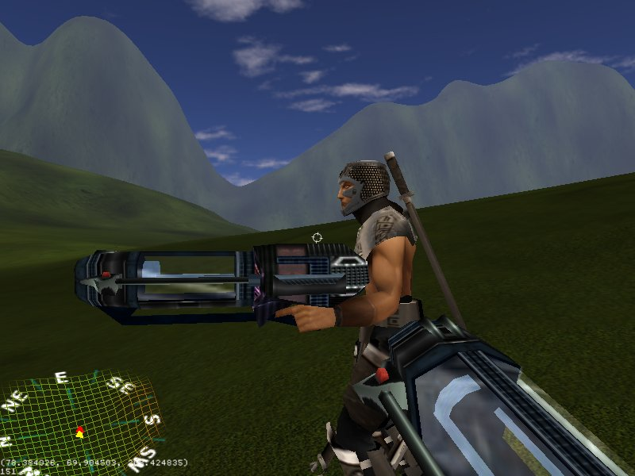
(Shot from first-person perspective. These are temporary Quake 3 models.)

Multiplayer
Multiplayer will be co-op style gameplay. It will play just like single player, except instead of having one security guard the additional players will take on the roles of additional security guards to fight off the enemy militia.

Game Flow

The player(s) will start from the transport ship crash site and then explore around the map and attempt to defeat all the enemies at the nine bases. After defeating each base, the player will receive an additional snippet of the story. If the player looses all health, then he will die and be respawned at a player spawn pad location. The bases can be defeated in any order. The story sequence that will be played is dependent on how many bases the player has defeated (i.e. When the player defeats the second base, he will view the second story sequence, when he defeats the fifth base, he will view the fifth story sequence, and so on.)

Sequence Name | Occurs when… | Description
Intro | Player(s) begin a single or multiplayer game. | A prison transport ship is traveling through space, passing by the planet of HSX-231-R6-B. A missile emerges from the planet, strikes the ship, and the ship will plummet to the planet below. From the in-game first-person perspective, the security guard says, “uhh… What happened? The prisoner has escaped! I had better search around and find out what happened.”
Base One | After the player defeats his first base and it explodes. | A militia soldier stumbles out of the base and says, “uhh… you mad man… how did you kill… them… all… uhh… (Blood splatter).”
Base Two | After the player defeats his second base and it explodes. | The disembodied head of a militia soldier flies out of the base and onto the ground and says, “You! Come back here! I’ll bite your legs off! Come on you yellow bastard!” and the head continues to rant until the end of the game or until the player kills it.
Base Three | After the player defeats his third base and it explodes. | A militia soldier stumbles out and says, “Oh please, don’t kill me. Please sir.” Security Guard says, “Talk!” Militia says, “Your prisoner… we were freeing our boss… I’m just a pawn in their game… please sir!” The militia soldier continues to beg or mercy until the game ends or until the player kills him.
Base Four | After the player defeats his fourth base and it explodes. | Security guard says, “Where is the prisoner?” Militia soldier says, “He’s in another base. (Pause) No, really. He is.”
Base Five | After the player defeats his fifth base and it explodes. | Soldier says, “Sorry sir, but your prisoner is in another base.”
Base Six | After the player defeats his sixth base and it explodes. | Soldier says, “Sorry sir, but your prisoner is in another base.”
Base Seven | After the player defeats his seventh base and it explodes. | Soldier says, “Sorry sir, but your prisoner is in another base.”
Base Eight | After the player defeats his eighth base and it explodes. | Soldier says, “Sorry sir, but your prisoner is in another base.”
Base Nine | After the player defeats his ninth base and it explodes. | The mafia ringleader appears and says, “Alright you annoying little bastard, we’re taking you to our main base for questioning.”
Ending | After ninth base sequence ends. | A military convoy appears, apprehends the security guard(s), take them back to their main base, the credits roll, and then it returns to the main menu.

Input Design

The input will be typical of any first-person shooter. W-A-S-D will be used for moving forward, back, strafing left, and strafing right. The Space Bar will be for jumping, and the Shift key will be for crouching. The Mouse will be used for looking around and firing. The number keys (1,2,3,4,5,etc.) will be used for changing weapons. All button controls can be customized from the Settings screen, which is accessed from the main menu.

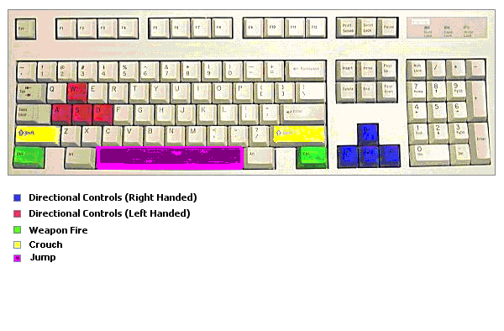
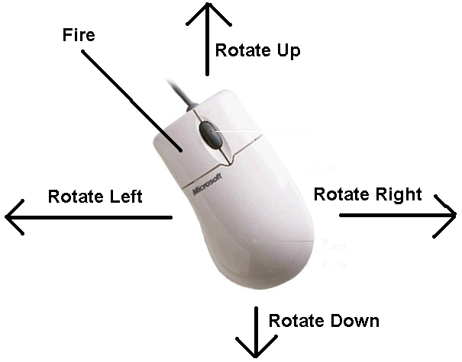
Pointing and clicking on the menu options with the mouse will the method for handling menu navigation.

Player Design

Player Description
The player will be a male prison security guard. He will appear to be a humanoid wearing black full-body suit along with helmet and open visor.

Inventory
The player will have three statistics: health, ammo, and weapons. The player’s health bar is illustrated by an elongated blue rectangle in the upper right hand corner of the screen that shortens as the player receives damage (being shot by an opponent, etc.).

If the rectangle is shortened by over 75%, then the blue color becomes red.
When the rectangle is shortened by over 90%, it begins to rapidly blink (oscillate between red and black). When this rectangle has been depleted, it means that the player has died.
A number in the lower right hand corner of the screen will represent the player’s ammo. The player’s weapons in his inventory will not be graphically represented, except for the one that is currently equipped which will appear to be sticking out on the lower portion of the screen as if the player is holding it. The different weapons can be accessed by pressing the different number keys (1,2,3,4,5,etc.).

In game UI

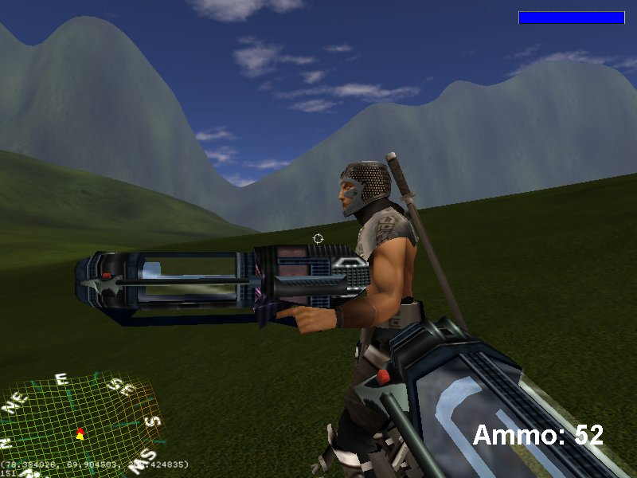

The In game UI is basically the same as any first-person shooter. At the bottom of the screen, the player’s currently equipped weapon is displayed, with a crosshair in the middle of the screen indicating where the player’s weapon is aiming. The player’s health bar will be displayed in the upper right hand corner, and the player’s ammo count will be displayed in the lower right hand corner.
In the lower left hand corner there will be a radar. The radar is a circular semi-transparent object used to show relative positions of nearby characters. Using a polar coordinate system (with the current player at the origin), red dots are used to illustrate the positions of hostiles and yellow dots are used for allies. The radar has a range (radius) of 25 meters.

Enemy Design

Enemy Descriptions

There will be two enemy models, a Male Militia Soldier and a Female Militia Soldier. They will both be humanoid wearing full body camouflage clothing and makeup. They will both be equipped with Pistols that fire Lead Bullets, and they will both move and act the same way.
The militia soldiers will have three types of AI: Smart, Stupid, and Camper. The Smart AI will aggressively move towards you, attack you more frequently, dodge your bullets more frequently, and do it’s very best to annoy you and kill you. The Stupid AI will run around you in a circle, only shoot at you from behind, and sometimes move into your bullets. The Camper AI will stay a safe distance from the player, stay in one spot, and shoot at the player like a sniper.

Model Used | AI Name | Description
Male/Female Militia Soldier | Smart | Aggressively moves towards you, attacks you more frequently, dodges your bullets more frequently, and does it’s very best to annoy you and kill you.
Male/Female Militia Soldier | Stupid | Runs around you in a circle, only shoots at you from behind, and sometimes moves into your bullets.
Male/Female Militia Soldier | Camper | Stays in one spot and shoots at the player like a sniper.

Each enemy will die after being hit two times with a Lead Bullet.

Other Design

Blood Splatter and Explosions

When a bullet strikes a character, a large amount of blood is sprayed into the air, eventually disappearing. If that character is human-controlled, that person’s screen will have a momentary red glow around the perimeter of the view. There are some explosive crates within the game. Three hits from any bullets will induce a fiery explosion that can damage any character in its immediate surroundings. The amount of damage is dependant upon the inflicted character’s distance from the center of the explosion. These features add to the realism of the game making it a more lively and interesting experience.

Ammo Refill Spawn Pads

Throughout the map there will be various ammo refill pads that will spawn ammo refill items. When the player walks over the item, he will automatically pick it up and receive 50 Lead Bullets in his ammo reserve. At the beginning of the game, all the spawn pads will have an item spawned. After the player picks up a refill, the pads will wait one minute before respawning another refill.

Health Refills Spawn Pads

Throughout the map there will be various health refill pads that will spawn health refill items. When the player walks over the item, he will automatically pick it up and receive a 100% full health refill. At the beginning of the game, all the spawn pads will have an item spawned. After the player picks up a refill, the pads will wait one minute before respawning another refill.

Enemy Spawn Trigger Regions

Various regions of the map will be set aside as Enemy Spawn Trigger Regions. When the player enters one of these regions, a flood of enemies will appear from the distance and charge at him. The number of enemies that are spawned will be modifiable using our game’s scripting feature. If the regions contains a base, then once the player defeats all of the enemies the base will explode and a story sequence will be carried out. The enemy AI will be programmed in such a way so that if he tries to run away, he will die. The only way for the player to survive will be to fight off the hoard of enemies.
The AI type of each enemy will be determined randomly in such a way so that an even number of each type is generated. The proportions of the number of each type will be modifiable using our scripting engine.

Bases

On the map there will be nine bases. The base will be a small encampment (about half the size of a 7-11), with a missile launcher showing somewhere, indicating that it might be the launching place from which the missile, that shot down the transport ship, was fired. The base must be small enough so that nobody can walk into it.

After defeating all of the enemies surrounding each base, the base will explode and a story sequence will be played out.

Player Spawn Pads

On the map there will be player spawn pads. When the player dies, he will be respawned at the nearest pad.

In game Option

All game settings can only be set from the main menu before a game begins. There are no in game options.

Level Design

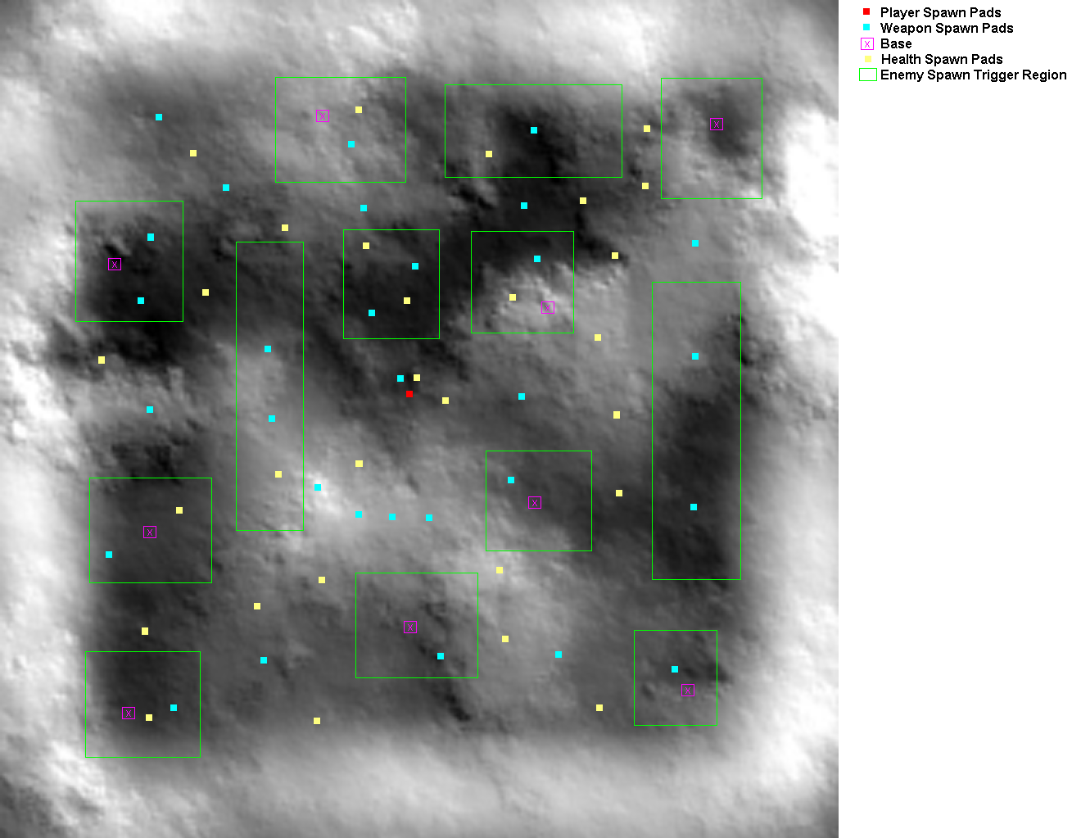

In the game, there will be one terrain map. The map will be grassy, and surrounded by mountains that prevent the player from escaping. On the map will be player spawn pads, nine bases, ammo (weapon) spawn pads, health spawn pads, and enemy spawn trigger regions.

User Interface

User Flow

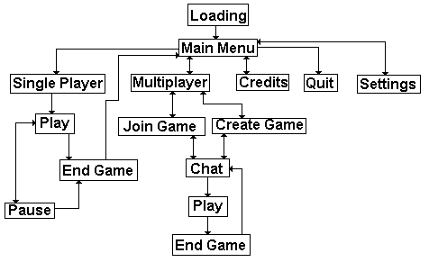

Note: Chat is the pre-game screen. No chatting will be allowed on the pre-game screen.

Main Menu

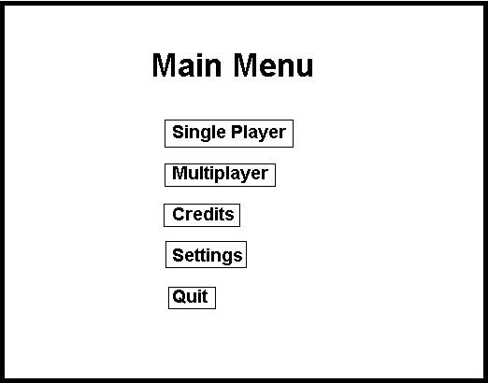

Single Player

Choosing Single Player will start a single player game. As soon as the player clicks on the button, the intro will begin, and then the game will start.

Multiplayer

Choosing this option will bring the player to the Multiplayer Create/Join menu.

Credits

Choosing this option will bring the player to the credits screen.

Settings

Choosing this option will bring the player to the Settings Menu.

Quit

Choosing this option will cause the game to exit and free all resources.

Settings Menu

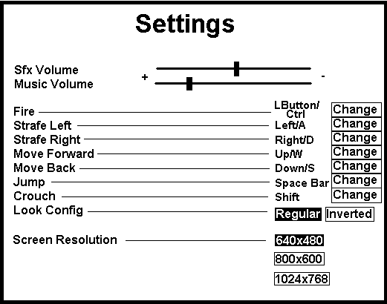

Volume Control

Using the sliding control bars, the player can adjust the volume of the sound effects and music.

Button Configuration

Here are listed the controls for the game. If the player wishes to change any of the button settings, he will have to click on the Change button adjacent to the listing. After doing so, a window will pop up that says, “Press the button you wish to change to.” The player will then press the button that he wishes to change the control to, and then the new setting will take affect.

Look Configuration

Here the player can choose which looking configuration he wishes to use: Regular or Inverted. In regular mode, moving the mouse forward will cause the camera to rotate up, and moving the mouse backward will cause the camera to rotate down. In inverted controls, the up and down movements will be switched – moving the mouse forward will cause the camera to rotate down, and moving the mouse backward will cause the camera to rotate up. Regular is the default setting.

Screen Resolution

There are three screen resolutions for the player to choose from: 640x480, 800x600, and 1024x768. As soon as the player clicks on the new setting, the screen resolution will change. 640x480 is the default setting.

Back Button

The Setting menu will also have a back button which will return the player to the main menu.

Multiplayer Create/Join Menu

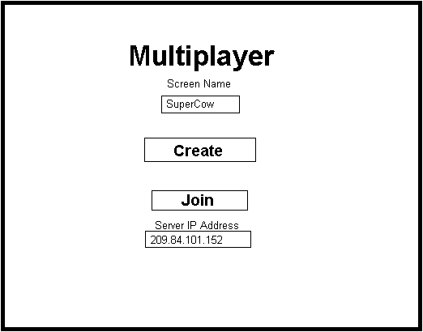

Screen Name

Below the text “Screen Name” there will be an edit box where the player will enter a screen name. If the player enters the same screen name as another player that has already joined, then a number will be added to the name (i.e. if another player with the name SuperCow has already joined, then the player’s name will be set to SuperCow2). If no screen name is entered, then the player will be given the name SuperCow by default.

Create

The player will press this button when he wishes to host a network game.

Join

The player will press this button to join a network game. Before doing so, however, he must enter a correct IP Address in the text box below. If an incorrect address is entered, then an error will occur which will cause the game to quit.

Server IP Address

In this edit box the player will enter the server’s IP address of the game he wishes to join. The string is set to “209.84.101.152”, the IP address of the network programmer’s computer, by default.

Back Button

Pressing this button will cause the player to return to the main menu.

Multiplayer Pre-game Screen

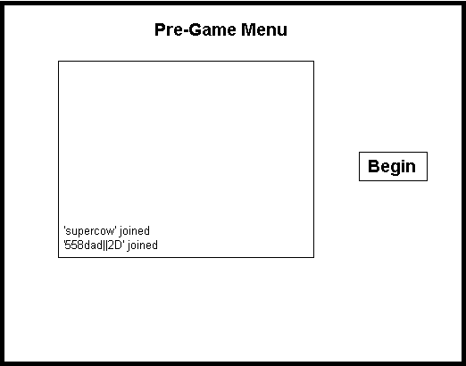

Text Box

In the middle of this menu screen there will be a text box that displays who has joined the game thus far. This text box will not display chat messages. There is no chatting option in the pre-game menu screen.

Begin Button

If the player decided to be the server, then he will see the begin button on the right side of the screen. When the server player presses this button, the game will begin. If the player is not the server, then he will not see that button, and will thus not be able to press it.

Back Button

If the player presses this button, he will return to the multiplayer create/join screen. If the server player presses the back button, then all players will return to the multiplayer create/join screen.

HUD/GUI

The HUD will have a basic appearance very similar to most other first-person shooters. The player will be viewing the world from a first-person perspective, the currently equipped weapon will be displayed in the lower right corner, the ammo count will be displayed in the lower right corner, the health bar will be displayed in the upper right corner, and the radar will be displayed in the lower left corner.

Credits

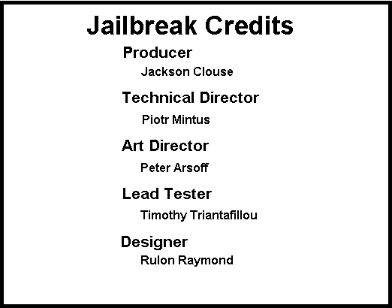

The credits screen will list all of the team members under their perspective hats: Producer – Jackson Clouse, Technical Director – Piotr Mintus, Art Director – Peter Arsoff, Lead Tester – Timothy Triantafillou, Designer – Rulon Raymond. There will also be a back button which will return the player to the main menu.

Pause Menu

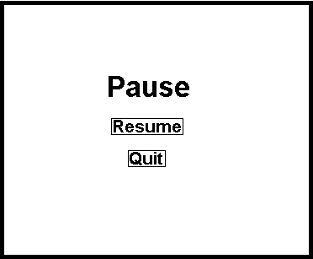

At any time during play the player can press ESC to bring up the pause menu. If the pause menu is brought up during single player, all activity in the game will freeze until the player presses Resume. If the pause menu is brought up during Multiplayer, however, then all game activity will resume and all other players will simply see him standing still.

Resume

Pressing this will cause the game to resume.

Quit

Pressing this button will quit the game and return the player to the main menu.

Art, Sound

Art Requirements

There will be two types of art required: 3D models and bitmaps. The 3D models will be used as objects in the game, and the bitmaps will be used for menu display.

Format

3D models will be stored in *.md3 format, the file format used for storing Quake 3 models. Bitmap files will be stored in *.bmp format, the standard format for storing bitmaps. There is one exception, however – the terrain will be stored as a height map which the game’s engine will read in order to generate the terrain at run time.

Style

Both the 3D models and the Bitmaps will use the standard format for storing *.md3 and *.bmp files, respectively.

Art List

Model Table

Name | Description | Max Poly Count | Animations
Security Guard | Humanoid wearing black full-body suit along with helmet and open visor | 1500 | Walk, Crouch, Jump, Get Hit, Die
Mafia Prisoner | Humanoid wearing loose orange standard issue prison garb | 1500 | Walk, Crouch, Jump, Get Hit, Die
Male Militia Soldier | Humanoid wearing full body camouflage clothing and makeup | 1500 | Walk, Crouch, Jump, Get Hit, Die
Female Militia Soldier | Humanoid wearing full body camouflage clothing and makeup | 1500 | Walk, Crouch, Jump, Get Hit, Die
Pistol | A standard issue pistol. | 1500 | Fire Weapon
Lead Bullet | A regular-looking lead bullet, which is fired from the Pistol. | 1500 | None
Tree (one model) | The terrain will be littered with these trees. They will be about twice the height of a humanoid character, with the green part starting on the upper half of the tree. | 1500 | None
Rock (one model) | The terrain will be littered with these rocks. It is gray with a smooth shape, like the rocks in Halo but smaller, about half the height of a humanoid character. | 1500 | None
Wooden Crate | The terrain will be littered with wooden crates that explode with collided with a lead bullet. The explosion will be handled by the game’s particle engine, and does not require animating. The crate should be a box shape. | 1500 | None
Health Power Up | The terrain will be littered with health power ups. It should look like an item that will restore your health. | 1500 | None
Ammo Power Up | The terrain will be littered with ammo refills (for lead bullets). It should look like a refill for lead bullets. | 1500 | None
Enemy Base | On the terrain there will be enemy bases. The base will be a small encampment (about half the size of a 7-11), with a missile launcher showing somewhere, indicating that it might be the launching place from which the missile that shot down the transport ship was fired. The base must be small enough so that nobody can walk into it. | 1500 | None
Prison Transport Ship | This is the transport ship that was carrying the prisoner and was shot down. | 1500 | None

Bitmap Table

Name | Description
Main Menu Background | The background for the main menu screen.
Multiplayer Background | The background for the create/join multiplayer screen.
Pre-game Background | The background for the pre-game screen.
Settings Background | The background for the settings screen.
Credits | The credits screen.
Pause Background | Background for the pause screen.
Press To Change Button Window | The window screen that comes up when the player is attempting to change the button configuration.
Single Player Button | From the main menu, the button that the player will select in order to begin a single player game.
Multiplayer Button | From the main menu, the button that the player will select in order to begin a multiplayer game.
Credits Button | From the main menu, the button that the player will select in order to view the credits.
Back Button | From all menus except the main and pause menu, the player will press this button to return to the previous screen.
Quit Button | From the main or pause menus, the player will press this button to quit the game.
Settings Button | From the main menu, the button that the player will select in order to change the game settings.
Change Button | From the settings screen, the player will press this button to change the configuration of a button.
Regular Button | From the settings screen, the player will press this button to switch the looking configuration from inverted to regular.
Inverted Button | From the settings screen, the player will press this button to switch the looking configuration from regular to inverted.
640x480 Button | From the settings screen, the player will press this button to set the screen resolution to 640x480.
800x600 Button | From the settings screen, the player will press this button to set the screen resolution to 800x600.
1024x768 Button | From the settings screen, the player will press this button to set the screen resolution to 1024x768.
Sfx & Music Slide Bar | From the settings screen, the player will press this button to set the volume of the sound effects and music.
Create Button | From the multiplayer screen, the player will press this button to host a game.
Join Button | From the multiplayer screen, the player will press this button to join a game (after entering the server’s IP address)
Begin Button | From the pre-game screen, the server player will press this button to begin a game after everyone has joined. All non-server players will not see this button.
Resume Button | From the pause menu, the player will press this button to resume the game in progress.

Animations

Each model will have it’s own set of animations. Some models, such as the humanoid models, will need to have a set of pre-programmed animations that the game will call upon when appropriate, such as walk, die, and get hit. Other models, such as the bases, will have no animations and will instead be animated by the game’s engine (the base will be surrounded by an explosion, followed by streaming smoke after the base is defeated, which are all handled by the particle engine).

Backgrounds

Aside from the above listed menu backgrounds, the terrain level will have a skybox background surrounding the environment. It will be a blue sky with some clouds scattered around it. It will not be animated.

Textures

All models will have textures applied to them. For descriptions of each texture, see the above table.

Fonts

Two fonts will be used in the game – Lucida console, for the game console, and Verdana, for displaying the player’s current health. All fonts will be loaded from *.png files.

GUI

The Graphical User Interface for the menus will be a series of loaded bitmap images. See the above table for details.

Sound Requirements

Format

All sound effects and voices will be loaded using the standard *.wav file format. Music will be loaded using the *.ogg file format.

Style

Both the *.wav and *.ogg will use the standard style used for those formats.

Sound List

SFX

Name | Description | Max Size in KB | Played When…
Explosion 1 | Pshh-ooomm!! | 500KB | An explosion occurs.
Explosion 2 | Ba-Doooomm!! | 500KB | An explosion occurs.
Missile Hit | Sound of a missile hitting a transport ship. | 500KB | The transport ship gets hit by the missile.
Pistol Fire | Bang! | 500KB | A Pistol is fired.
Pistol Reload | Pistol clip being inserted into a pistol. | 500KB | A Pistol ammo refill is acquired.
Pistol Empty | Empty pistol click. | 500KB | The pistol ammo is empty.
Walking on Grass | The pitter patter of steel toe booties walking on grass. | 500KB | The player and enemies move around on the grass.
Blood Splatter | Squishy, fleshy sound. | 500KB | A humanoid is hit with a lead bullet.
Menu Navigation 1 | Positive-sounding blip sound. | 500KB | The player presses: Resume, Single Player, Multiplayer, Create, Join, Begin, Settings, Change, 640x480, 800x600, 1024x768, Regular, Inverted.
Menu Navigation 2 | Negative-sounding blip sound. | 500KB | Player presses: Quit, Back.
Menu Navigation 3 | Blip sound played when typing. | 500KB | Typing in user name and server IP address.
Menu Navigation 4 | Moving scroll bar sound. | 500KB | Moving Sfx and music volume scroll bars left and right.
Victory Sound | Uplifting positive sound. | 500KB | The player defeats a base.
Defeat Sound | Disappointing negative sound. | 500KB | The player dies.
Male Moan | Sound of a male humanoid moaning in pain. | 500KB | A male character is hit with a lead bullet.
Female Moan | Sound of a female humanoid moaning in pain. | 500KB | A female militia is hit with a lead bullet.

Music

There will be one music track that plays both during menu navigation and game play. It will be stored in the *.ogg file format. It will be fast-paced, and first-person shooter friendly.

VOX

Several voice bits will be needed for each story sequence. See game flow sequence table for details. All voice bits will be stored in *.wav format, and will be no larger than 500KB in size each.

Technology

Technical Analysis

For the production of this game we will be exploring some new technologies which will make our game look really cool. The game engine will feature a robust 3D graphics engine that utilizes OpenGL, a custom-made physics engine, custom-made AI, and a networking module customized for a first-person shooter.

Technical Requirements

Naming Conventions

Classes inside the Engine Module will be prefixed with CMS* (ie. CMSSound).

typedef class DLLEXPORT CMSSound
{
}*LPCMSSOUND;

Classes in game will not have any special prefixes:

typedef class CSound
{
}*LPCSOUND;

Structs and Enums are in upper case

typedef struct _MYSTRUCT
{
...
}MYSTRUCT,*LPMYSTRUCT;

enum MYENUM
{
};

Structures, flags, enums for a certain engine module class are stored in other files. For example the CMSGraphics class uses CGC* structs, flags and enums, while CMSSound uses CSC*.

Version Control

Every function and file will have a header that will list the version number and a description of what has changed. Whenever a team member modifies a file or function, he will need to add comments to the header.

Tools

Models and Animations Editor

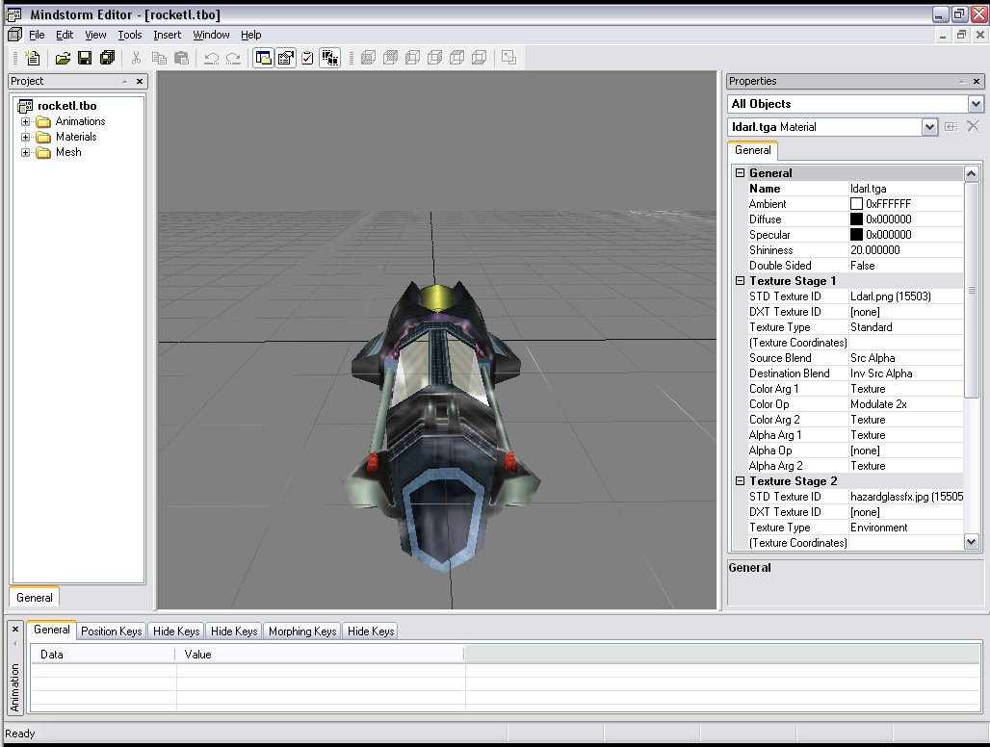

As with last semester, we will be using Piotr’s Mindstorm Editor to edit models, animations, and other 3D graphics related things. His robust package will allow us to easily edit many configurations of the game play very easily.

Sound Editor

Sound will be edited using the standard windows sound edit tools, such as Sound Recorder.

Installer

For the installer we will be using the Inno Installer. We are somewhat unknowledgeable in how this technology works, so we will have to learn about it during the course of production.

Marketing

Target Market

The target market for Jailbreak is gamers age 17+ and above whom like fast paced action oriented first-person shooter games. Because this is a first-person shooter it will most likely receive an M or Mature ESRB rating.

Genre

This game is a first-person shooter, and will be marketed to the first-person shooter audience.

Competitors

Our top three competitors will be Quake 3 Arena, Half-Life, Unreal Tournament, and Halo. Our major advantage will be that our software is free.

Top Performers

Quake III Arena

Platform: PC
Publisher: Activision
Release Date: 12/1999
Current Price: around $30

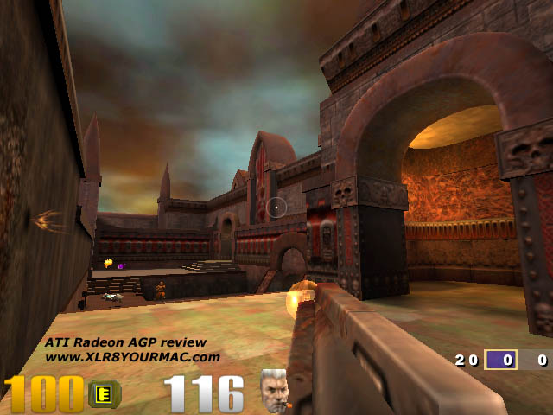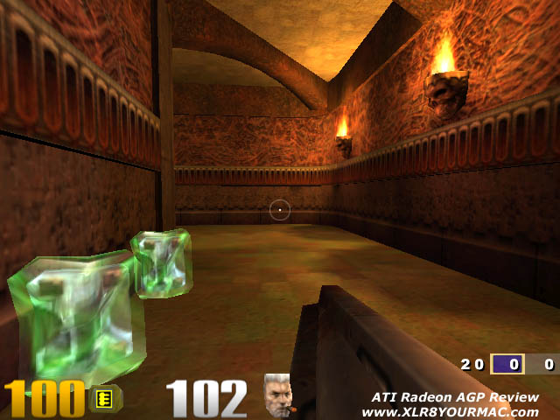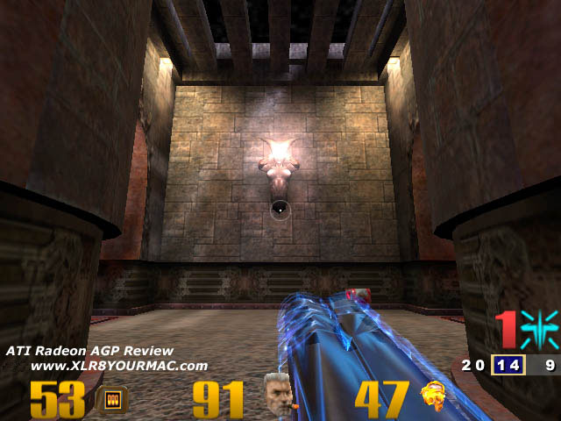

This will be our number one competitor. The game is fast action paced and has a huge user group. Although what it has in graphics it lacks in storyline. Quake III Arena is focused mostly on multiplayer, which takes away from a fun single player experience.

Half-Life

Platform: PC
Publisher: Sierra Studios
Release Date: 11/1998
Current Price: around $30

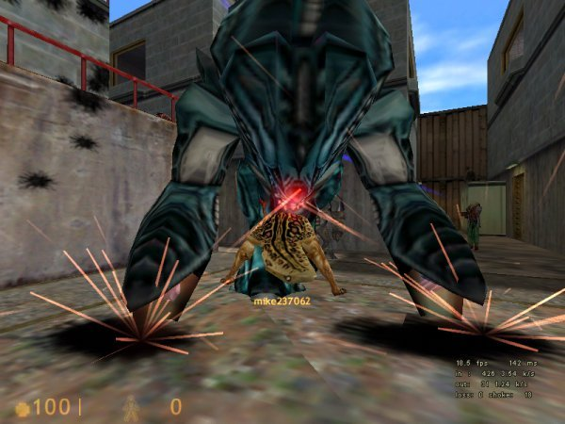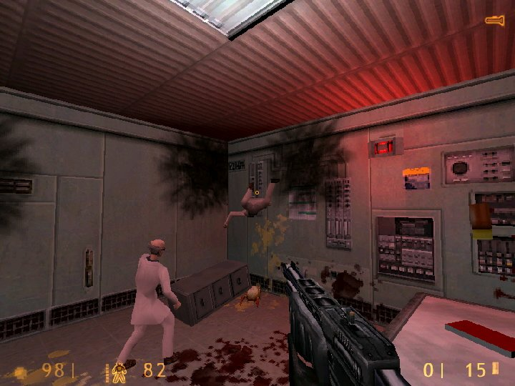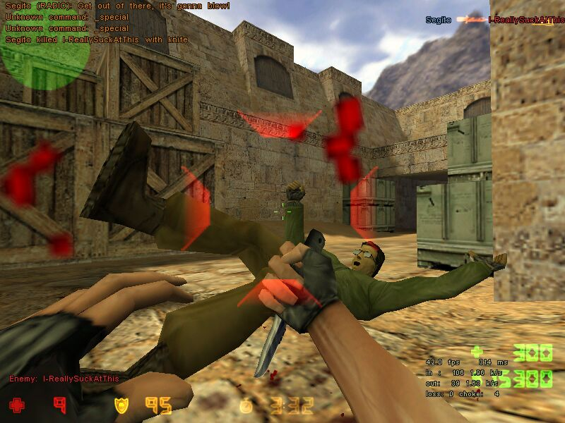

Half life has got a huge user base and an extremely huge mod community. The most famous of the mods includes Counter Strike and Team Fortress.

Unreal Tournament

Platform: PC
Publisher: GT Software
Release Date: 11/1999
Current Price: around $10

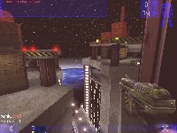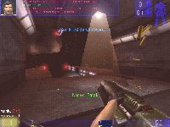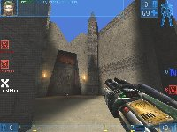

Unreal Tournament was when it came out in direct competition with Quake III Arena.

Halo

Platform: Xbox
Publisher: Microsoft
Release Date: 12/2001
Current Price: around $50

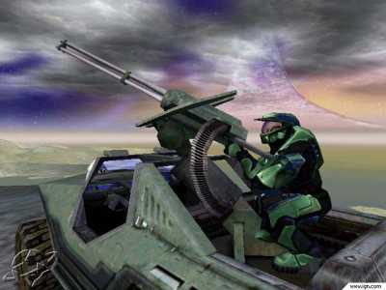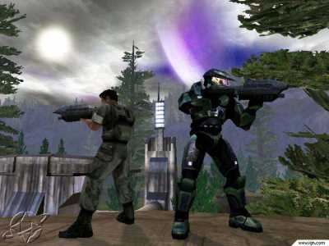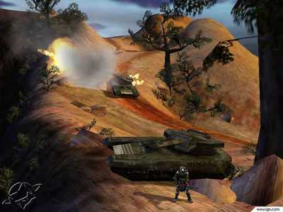

Halo is a new competitor to the First Person Shooter market. It has entered the market with a bang. It has among the best graphics and the most thorough story line and game play of any first person shooter. Its weakest point is probably the controls, a PC keyboard and mouse is much better for a first person shooter.

Feature Comparison

Jailbreak | Quake 3 Arena | Half-Life | Unreal Tournament | Halo
* Realistic physics for collisions, projectiles, and motion  * Challenging Serious Sam-like AI  * 2 to 6-player networked co-op games  * Intense fast-paced combat simulation  * It’s free! | * Completely new graphics engine developed by ID Software using the latest technology to achieve both smooth and curved surfaces, realistic textures and environmental effects such as fog and flowing lava just to name a few.  * 3 Different player classes to choose from. Light, Medium, and Heavy, all with their own strengths and weakness including armor protection and player speed.  * A deadly arsenal of weapons ranging from shotguns, to rocket launchers, lightning guns to flame throwers, and even the dreaded BFG. Choose the right weapon for the right situation, and you just might survive.  * A vast array of items to help you stay alive. With health kits and body armor to better shield you, along with the feared "Quad Damage", with which you can cause havoc upon your foes.  * State of the Art Enemy Intelligence. Play against computer bots and see if you have what it takes to defeat these deadly drones. | * Hazard Course training area for practicing movements, special maneuvers, and weapons use  * Seamless level transitions  * A variety of real-world, experimental, and alien-world weapons  * 32 player Internet/LAN support  * World craft 2.0 beta level editor included | * More than 100 insane maps to choose from; tutorial levels give you time to polish your combat skills  * Intense "Rocket Arena" mode pits you in gladiator-style combat against your opponent - no extra weapons, no power-ups, just you and your opponent in a battle to the end!  * "Chaos" mode brings wild new weapons including a deadly sword to slice and dice with and hilarious Proximity Mines that giggle and yell as they chase down your enemies!  * Experience jaw-dropping graphics and animation without a 3D accelerator  * Intense multiplayer gameplay supports up to 16 players without requiring an Internet connection; Internet play pits you in furious head-to-head combat with other UT fans!  * Pounding music and sound effects bring the game to life | * Huge Weapon Variety - Vanquish your enemies with a vast array of Human or Covenant weaponry ranging from the stealthy (semi-automatic pistols and needler guns) to the fierce (rocket launchers and flame throwers).  * Vehicle and Foot-Based Action - Tackle missions anyway you choose - be it storming an enemy base or taking the wheel or gunnery position of a variety of powerful vehicles. Vehicles range from stolen Covenant flyers to Human buggies and more.  * Indoor and Outdoor Combat - Fight seamlessly in Halo's ultra-realistic indoor and outdoor environments as you hunt the Covenant in a variety of single player missions and multiplayer battles.  * Intense Multiplayer Shoot-outs - Form a team, choose a role, and fight cooperatively with your friends, battle it out Deathmatch style via intense split screen, LAN-play or fight co-op with a friend through the single player missions.  * Incredible Mission Variety - Fight the Covenant in a variety of missions as you uncover the dark secrets of halo. Among your many objectives - attack enemy outposts, raid underground labs for advanced technology, rescue fallen comrades, steal alien vehicles and weaponry and snipe enemy forces.  * Reality Bending Special Effects - Halo features the most advanced graphic system on the most advanced gaming platform in the world. Gunfire rips off the screen, explosions light up a living room, and environments blur the line between your couch and fantasy.  * Rich Sci-Fi Experience - Halo transports gamers into a science fiction universe fresh out of a Hollywood movie. With a detailed twisting story line, complex characters and cunning enemies, Halo will fulfill every sci-fi enthusiasts dreams.

Our major advantage will be that our game is free.

Retail Dollars

Game | Price
Jailbreak | $0.00
Unreal Tournament | $14.99
Quake 3 Arena | $29.99
Half-Life | $29.99
Halo | $49.99

Costs

Development

All game development will take place at DigiPen, and therefore the development cost will be zero (aside from the tuition expenses of each student, which have already been paid).

Sequels

Our game engine will be extremely versatile, reusable, and modifiable. Making a sequel will simply be a matter of designing more models and levels, and adding more powerful software technologies to our game engine to coincide with the inevitable advancements in hardware technologies. Reusing our code will cut the time and cost for developing a sequel dramatically.

Schedule

1st Playable

In the first playable demo, the player will be able to:
- Move around in the 3D environment with no collision.
- There will be no gravity or physics implemented.
- No weapons or enemies.
- The skybox and terrain will be visible, and render correctly.

2nd Playable

In the second playable demo, the player will be able to:
- Shoot weapons and kill enemies.
- No AI
- Collide with the ground, jump, crouch, and walk.
- Gravity and basic physics will be implemented.

Networking

In the early stages of the networking module, player will be able to:
- Host a game, join a game, see each other in the environment moving around smoothly.
- Shoot weapons and see each others weapons, etc.

Alpha

The alpha deliverable will have the following features implemented:
- Menus.
- Enemy Spawn Trigger Regions.
- Die and be respawned.
- Kill enemies.

Beta

The Beta deliverable will have every feature implemented, except it will be buggy and crash often.

Marketing

Focus Groups

Focus groups will be held when then become available. At the very least, they should take place after completion of the alpha deliverable. If they were to take place before that time, then the players would not be able to truly experience the game the way it was meant to be experienced.

Review

A design review will take place shortly after the focus groups. During the review we will determine the good and bad aspects of our game.

Demos

This game will have no demos.

Final

The final deliverable will have all the features implemented and be relatively bug free.

Risks

Technology

For this production we will be working with some new technologies that most of us are somewhat unfamiliar with, particularly with the 3D graphics, networking, and physics. As with almost any project that deals with using new technology, there is always the risk that obstacles may arise the we may not be aware. We may have to spend some time getting used to the technology.

Development

Due to the shortened semester length, we may have to work more feverishly to complete development of the game on time. Aside from that, there is the usual risk of unforeseen bugs showing up and having to spend unplanned amounts of time fixing them.

Team

Four members of the team have worked with each other before, and have had very few problems working together. There is, however, a new addition to the team, and personality conflicts may come up as we have not worked with him before and do not know what to expect.

One of the members of our team has also had a history of not completing his work on time. He also poses a risk to the success of the development. The other members of the team, however, do have a track record of doing their share of the work, so they shouldn’t pose too much of a threat.

Equipment

DigiPen has provided us with all the equipment we need. The only risk is if the equipment provided suddenly fails for some mysterious reason, and DigiPen is then unable to provide us with replacements. Although that scenario is extremely unlikely.

Competitors

Our game is free, we are not in this to make money, and therefore our competitors do not pose any threat to us.

Cost

All costs are paid. There is no risk of running over budget.

Schedule

As with all DigiPen productions, there is always the possibility that assignments from other classes can interfere with the scheduled development. We will do our best to make sure that does not happen.

Team Information

Company Background

Mindstorm is a team name for a game project at DigiPen Institute of Technology.

Designer

Rulon Raymond is a third year DigiPen student. Last semester he programmed the game’s physics, particle, and AI modules, and he will continue to improve upon them this semester and will also program the game’s scripting engine for handling game events.

Producer

Jackson Clouse is a third year DigiPen student. Last semester he programmed the game’s networking module, and will continue to improve upon it this semester.

Technical Director

Piotr Mintus is a third/forth year DigiPen student. Last semester he worked on the main pipeline of the game, the graphics, sound and input modules and the game tools, and will continue to improve the graphics engine and tools.

Art Director

Peter Arsoff is a third year DigiPen student. Last semester he worked on the console and the in-game radar, he will continue his work with the game menus.

Lead Tester

Timothy Triantafillou is a third year DigiPen student that joined our team at the beginning of this semester. From what he tells us, he is consistent in getting his work done, and will be a valuable member to our team if this proves to be true.

Mindstorm Productions

Producer
Jackson Clouse

Technical Director
Piotr Mintus

Designer
Rulon Raymond

Art Director
Peter Arsoff

Lead Tester
Timothy Triantafillou

